Antennas Assignment 3

Nick Cardamone (yes this is my own work, still annoying that I need to say that)

# Question 1

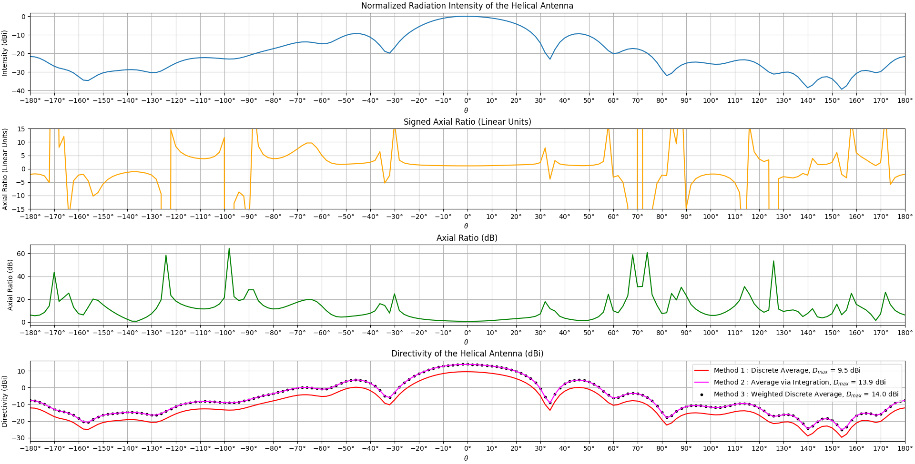

Figure 1

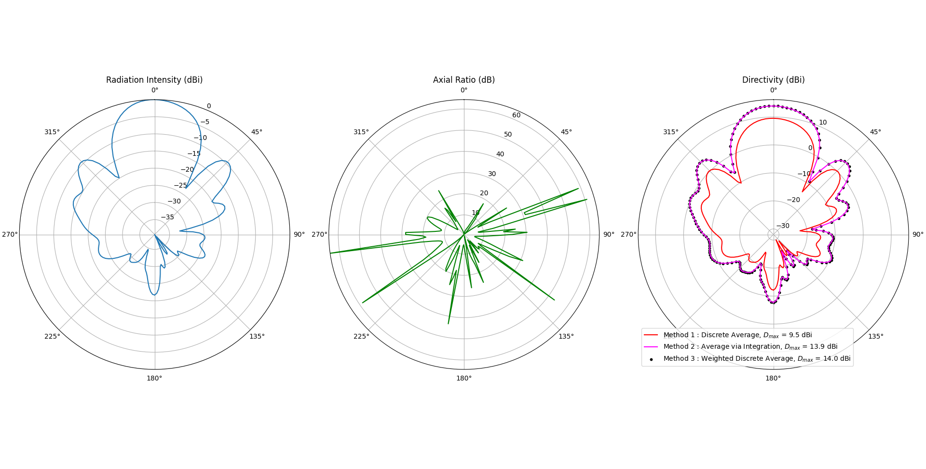

Figure 2

Polarization: circular polarization on the main lobe (0 dB on the green plot in figure 1), right hand polarization on the main lobe (positive on the yellow plot in figure 1). So RHCP where it matters, elliptical everywhere else (changes sense as well)

Yes it is possible to get the directivity from a single pattern cut PROVIDED that the radiation intensity is some known function of the known pattern cut. One example of when this is possible is when the radiation intensity is symmetric/ uniform about some axis (like a dipole antenna for example). To find the directivity, the radiation intensity needs to be divided by the average radiation intensity over the entire unit sphere. If that known function is able to map the know radiation intensity pattern cut into the rest of the unit sphere, that average can be computed and the directivity can be found. Otherwise, it is not possible.

Here is how to calculate directivity:

Three different methods were used to calculate the average of U

Method 1:

Method 2:

Method 3:

Below (figure 3) are the results from the 3 methods. The estimated directivity of this antenna is 14 dBi. Just taking a direct average of the U data does not work. A weighted average is needed since that is what the 2 dimensional average simplifies to over a sphere

Figure 3

If we were asked to generate this data ourselves in HFSS (like we should have been), it would be possible to find (an approximate) radiation efficiency if the materials/ environment were modeled accurately. Here is how to do it in HFSS (it can be directly extracted apparently): <https://www.researchgate.net/post/How_can_i_extract_antenna_efficiency_from_HFSS>

Otherwise, no

# Question 2

## Part A and B:

But this should be: Where does the extra 2h come from???????

## Part C

Figure 4

So first, the formula given for Prad in this question is only for , which means it is basically useless for the plotting that needs to be done. There are several workarounds that can be used (gauss quad integration over the sphere, numerical sum formula based on spherical wave mode expansion, a simple weighted average of U). I settled on using the sum formula presented by M.Dich in a paper from 1997. Figure 4 just verifies that this formula actually agrees with the other methods for calculating the radiated power. The right plot just shows the error between the methods (defined as method 1/ method 2), which is 0 dB (which is good). Also the given formula for Prad does work for (when you remember to add in the extra sin(theta) that is. sigh.)

Figure 5

Now onto the plots. As seen here, the longer the travelling wave antenna, the larger the directivity. But there are diminishing returns as the length increases. In addition to that, it can be seen that there is a slight directivity penalty when varying the value between 0 and 1, as this corresponds to scanning the beam. But that penalty seems to have a somewhat sudden impact. See the other question for more

## Part D

Figure 6

As the traveling wave antenna gets longer, the beam narrows and the directivity increases. It would be easy to say that the side lobe levels also go down as the antenna gets longer, however that is not the case. The first side lobe level is always about 13 dB down from the main peak regardless of the antenna length (within reason and for ). What does happen is the rate of decay of the side lobe levels increases with the antenna length, which in turn increases the directivity

## Part E: Part F (Below)

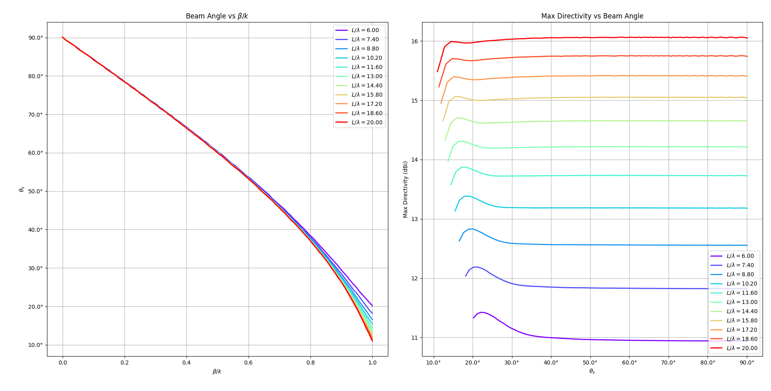

Figure 7

How to find : For all theta between 0 and , do a sweep over from 0 to 1 and record the maximum directivity. Then get the corresponding value that gives this (max) directivity. Do this for each value of antenna length as well. (i.e. just do a search for them over all possible parameters). Then plot. Also there isn’t really a directivity penalty as the beam scans. Not sure why/ what happened

# Question 3

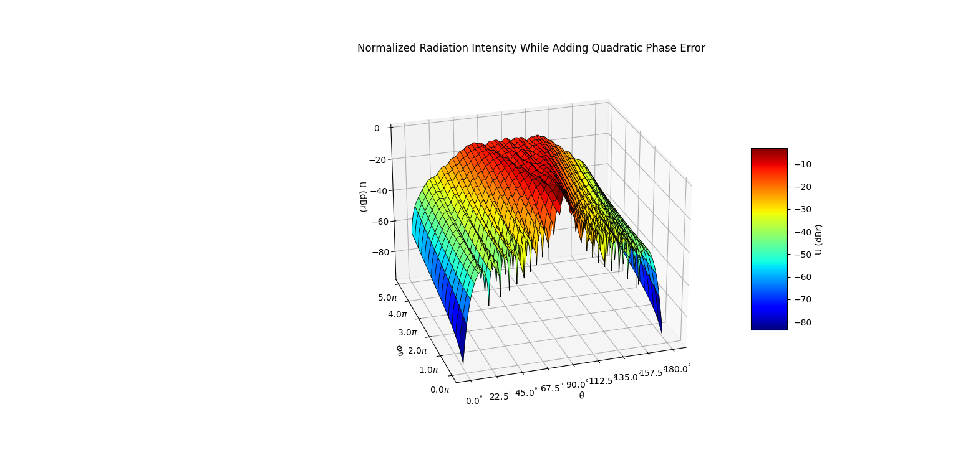

Figure 8

Figure 9

Figure 10

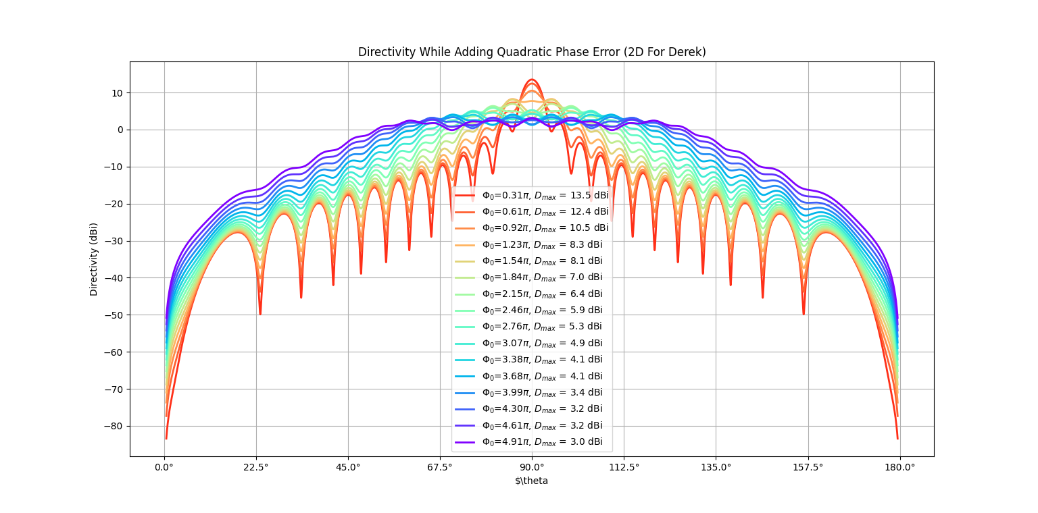

Figure 11

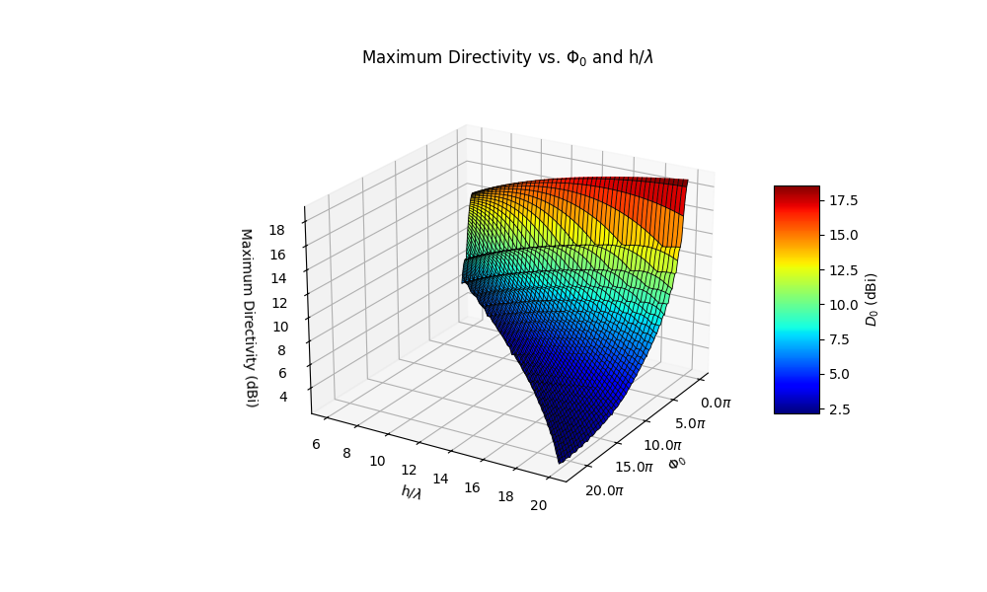

Figure 12

Figure 13

As seen in figures 8 through 13, the effect of the quadratic phase error is to lower the main lobe of the radiation intensity which has the effect of spreading out the beam (which in turn lowers the max directivity and increases the beamwidth of the antenna) and bringing up (and fill in) the side lobe levels. The figures 8 though 11 are for an antenna length of 6 wavelengths so it only takes a relatively small amount of quadratic phase error to distort the main lobe. As seen in figure 13, the shorter antennas are more susceptible to the phase error distortion (which kills the directivity) and the longer the antenna, the somewhat less sensitive it is to quadratic phase error. Quadratic phase error, is the phase shift of the current density/ distribution over the length of the antenna, and it is a quadratic function.